Forced Alignment using Montreal Forced Aligner (MFA)
Github url : https://github.com/Puneeth-Abhishek-6622/Research-Internship-Assignment
- Introduction
Forced alignment is the process of automatically synchronizing an audio recording of speech with its corresponding text transcript, marking the exact start and end times of words and phonemes.
In this project, the Montreal Forced Aligner (MFA) tool was used to align a set of speech samples with their respective transcripts. The objective was to build a fully automated alignment pipeline that produces precise TextGrid files, which can then be visualized and analyzed using Praat.
- Tools and Technologies used
Tool | Purpose
Docker | To create a consistent runtime environment for MFA
Montreal Forced Aligner (MFA) | Core alignment engine for speech–text synchronization
Praat | Visualization and analysis of phoneme and word boundaries

- Dataset description
- Files: 6 audio .wav files and 6 matching .txt transcripts
- Format: WAV, mono, 16 kHz recommended
- Naming rule: Audio and transcript filenames must match exactly (e.g., F2BJRLP1.wav ↔ F2BJRLP1.txt
Example directory structure:
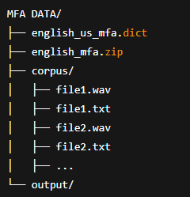
All audio files were 16 kHz, mono recordings, which meet the input requirements of MFA.
- Experimental Setup
- Create your project folder (example on Windows):

- Place the downloaded model files in this folder:
english_mfa.zip (acoustic model v3.1.0)
english_us_mfa.dict (dictionary v3.1.0)
- Create the required subfolders
- Copy or move all .wav audio files and their matching .txt transcripts into the corpus folder. Example:
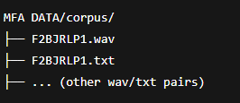
important: Filenames must match exactly (case-sensitive on Linux). Transcripts should contain only the spoken words (avoid punctuation where possible) and be uppercase if using ARPA-style dictionaries.
- Models used
  - English Acoustic Model (v3.1.0) :
Downloaded from MFA’s official release:
🔗 https://github.com/MontrealCorpusTools/mfa-models/releases/tag/acoustic-english_mfa-v3.1.0
File name: english_mfa.zip
  - English (US) pronounciation Dictionary (v3.1.0) :
Downloaded from MFA’s release:
🔗 https://github.com/MontrealCorpusTools/mfa-models/releases/tag/dictionary-english_us_mfa-v3.1.0
File name: english_us_mfa.dict
These pretrained models ensure reliable alignment for American English speech.
- Why docker was used
Instead of installing MFA manually (which involves complex Python and Kaldi dependencies), Docker was chosen for the following reasons:
- Consistency: Identical performance across all operating systems.
- Ease of setup: One-line command setup — no library conflicts.
- Portability: The same container can run on any computer or cloud system.
- Reproducibility: Guaranteed to produce identical results on any machine.
- Implementation steps

Step 1: Pull the Docker Image
To obtain the latest version of MFA:

Step 2: Run the Alignment
Run the following command to perform alignment on all files in your corpus folder.
This command mounts your local directory into the Docker container and runs the MFA alignment process.
Sample output of how the interface looks upon running the command
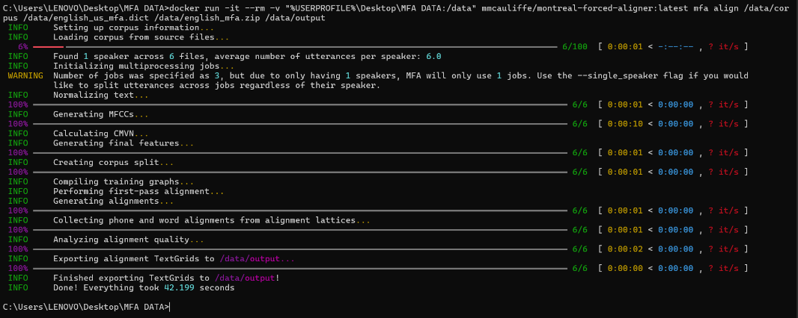
After this step all the textgrid files will be displayed in the output folder
- Key observations
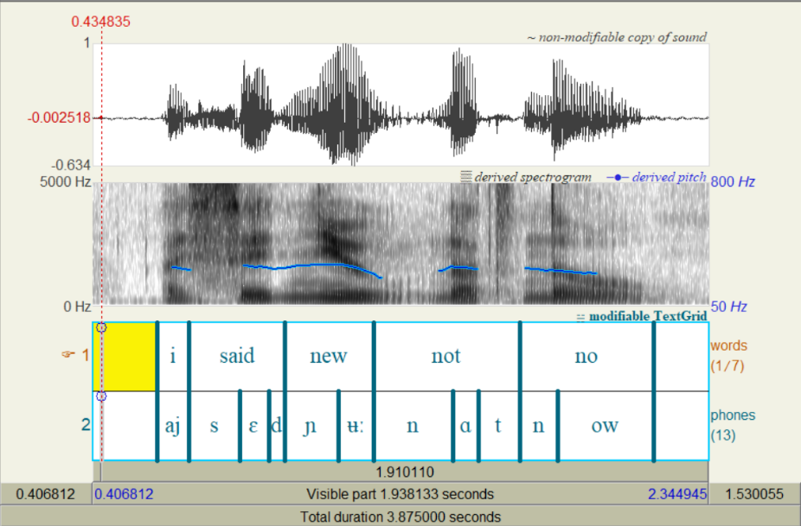

Sample 1 : I said new not no
- Word Boundaries: As with the first sample, word segmentation is correct.
- Phoneme Boundaries: This sample highlights the model's accuracy with nasal consonants and diphthongs.
  - Nasals: The /n/ phoneme in "new", "not", and "no" is cleanly segmented, aligning with the nasal formants visible in the spectrogram.
  - Vowels: The model correctly identifies the /uː/ vowel in "new" and the /oʊ/ diphthong in "no", with boundaries that accurately reflect the acoustic transitions.
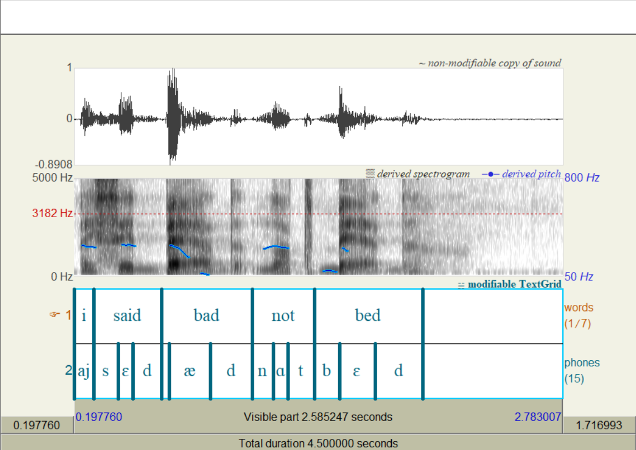
Sample 2 : I said bad not bed
- Word Boundaries: The model correctly identified the start and end of each word. The pauses between words are also implicitly segmented.
- Phoneme Boundaries: The phoneme-level alignment is highly accurate.
  - "said" (s ɛ d): The boundary between the initial fricative /s/ and the vowel /ɛ/ is clearly and correctly placed, aligning perfectly with the change seen in the spectrogram.
  - "bad" vs. "bed": The model successfully distinguished between the /æ/ and /ɛ/ vowels.
  - Stops: The stop consonants /d/ (in "said", "bad", "bed") and /t/ (in "not") are precisely aligned with their acoustic stop-gap and release-burst phases.

